In Transactions we need the Following:
Need MTN search for Transactions.
Add Search by Payer.
Add Search by Bank account.
Add Search by Affiliate.
For Successful Transactions there must be a provision to Add POP (Proof of Payment) adding functionality. POP can be sent to the MTOs email IDs. And POP can be downloaded to the system by the Customer Support person.
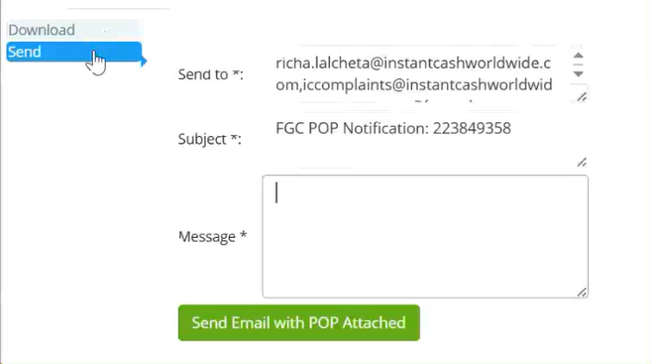
Add Payer Reference as a search option.

